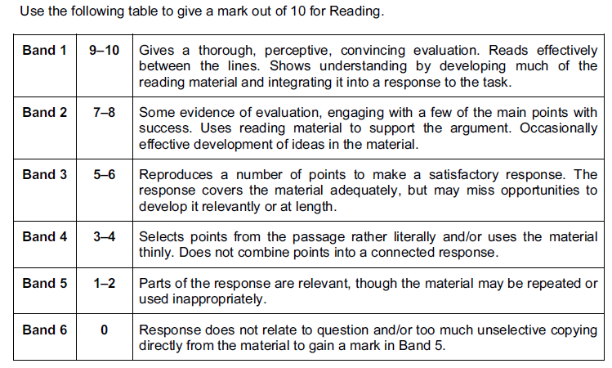
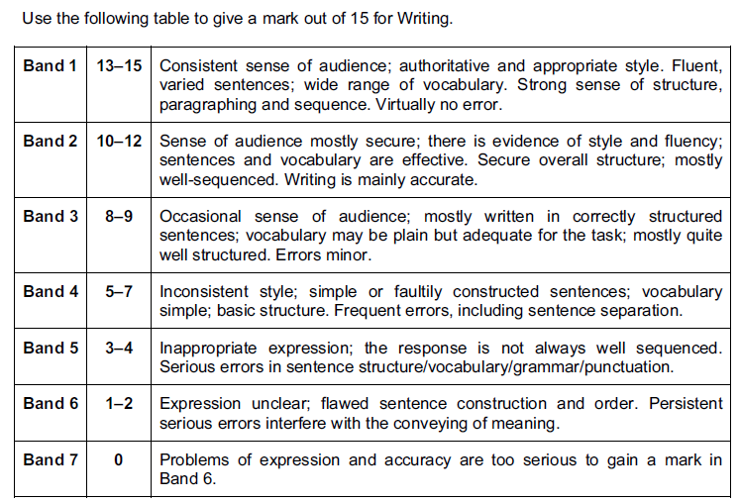
Language Paper 3, Question 1 Mark Scheme

Language Paper 3, Question 1 Mark Scheme

Language Paper 3, Question 1 Mark Scheme

